

SANA’A UNIVERSITY

FACULTY OF ENGINEERING MECHATRONICS ENGINEERING DEPARTMENT

Filling machine

Prepared by:
Motaz Essam Al Qershi
Project supervisor by :
Dr.Adel Rawea
Dr.Abdullah Dhiban

Overview
The SGP series fully pneumatic filling machines are newly designed for liquid, paste, and cream filling, and its filling amount can be adjusted as required based on the specified range, featuring high stability, reliability and filling accuracy. (Clevelandequipment, 2024)

1. Design Introduction:

- Project Description: automatic Liquid and Cream Filling Machine

- Objectives: Precise filling of liquids and creams with a volume of 25-250 ml

- Technical Specifications:
* Filling Speed: 15-60 bags/min
* Tank Capacity: 50 liters
* Made of 304 stainless steel

1. Functional Requirements:
Filling Capacity:
- The machine should be able to fill liquids in the range of 15ml to 250ml.
Fluid Variety:
- The machine should be able to fill a variety of liquids (such as water, oil, tomato paste, honey).
Filling Accuracy:
- Achieve high filling accuracy with a small error rate, estimated at ±1% or less of the specified filling volume.
Filling Speed:
- The machine should be able to fill a large number of packages in a short time, such as filling 15 to 60 bags per minute.
Ease of Operation:
- Easy and simple user interface to control the machine functions and make adjustments.

2. Performance Requirements:

Control System:
- Programmable Control System (PLC) or (Arduino) to set filling parameters and control the process efficiently.
Flexibility:
- Ability to adapt to different package sizes and shapes without the need for major modifications.

System Reliability:
- Ensure continuous operation without frequent breakdowns, and ensure simple and easy maintenance.
Material Specifications:
- Use of materials such as stainless steel (304 steel) to ensure durability and corrosion resistance, especially when filling reactive materials

1-2 Features
- All surface materials of this machine are crafted of 316 stainless steel, which features high acid-resistance and corrosion-resistance properties, as well as presenting a high quality finish.
- You can operate it safely and easily and adjusting the filling amount can be performed within the range as required with high accuracy.
- Its reasonable layout enables you to easily disassemble, safely operate, and easily clean the filler.
- Due to a total lack of electrical components, this filler can be used safely in a wide array of hazardous or moist environments. (Clevelandequipment, 2024)

1-3 Parameters
Item |  | SGP-250
Available range |  | Cream/Paste/Liquid
Filling range | Cream | 25-250ml
Filling range | Liquid | -
Filling accuracy | Cream | ±2%
Filling accuracy | Liquid | ±1%
Working air pressure |  | 0.4-0.5MPa
Throughput |  | 0-50 bottle/minute
Outline (length x width x height) |  | -
Net weight |  | -
Note: For this series of machine, the maximum liquid amount to be filled should be less than 5%-10% of the cream amount. (Clevelandequipment, 2024) (FK SPEEDA, 2023)

2. Engineering Calculations:
- Flow Calculations: 25-250 ml per filling cycle
- Pressure Calculations: 0.6 MPa
- Load Calculations:
* Tank Weight: 4.6 kg
* Body Weight: 25 kg
* Total Load with Liquid: (FK SPEEDA, 2023)

1. Basic fixed weight of the machine:
- Machine frame: 25 kg
- Empty tank: 4.6 kg
- Total empty machine weight = 29.6 kg (FK SPEEDA, 2023)

2. Calculating weights according to the material (tank capacity 30 liters):

A. Epoxy (Araldite LY 5052):
- Water density = 1.17 kg/L
- Water weight = 30 liters x 1.17 kg/L = 35.1kg
- Total weight = 29.6 kg + 35.1kg =64.7kg

B. Epoxy (Aradur 5052):
- Epoxy (Aradur 5052) density = 0.94kg/L
- Epoxy (Aradur 5052) weight = 30 liters x 0.94 kg/L = 28.2 kg
- Total weight = 29.6 kg + 28.2kg = 57.8 kg
3. Summary of total weights:
- With Epoxy (Aradur 5052) : 57.8 kg
- With Epoxy (Araldite): 64.7 kg (ROBERSON J. A., 1976)

1. Calculation of forces on the mounting bases:
Maximum weight = 64.7 kg (in case of Epoxy (Araldite))
- Weight force = Mass × Ground acceleration
- Weight force = 64.7 kg × 9.81 m/s² = 634.707 N (J.L.Meriam, 1807)
Design force = safety factor * Weight force
- Required safety factor = 1.5
- Design force = 634.707 × 1.5 = 952.06N (.Mccormac, 2010)

To calculate the stress due to the total weight (Body +Hopper + load) and its effect on the bases:

1. Hopper empty weight: (W{hopper}) (W{hopper}=4.6kg).

2. Load inside the Hopper (such as epoxy): (W{load} =64.7 kg).

3. Body weight: (W {Body}) (W {Body}=25kg).

Total Weight:

W{total} = W{hopper} + W{load} + W {Body}.

W{total}=4.6+64.7+25=94.3kg

1. Calculate Total Weight Force:

The force resulting from the total weight on the device:

F {total weight} = W{total}*g

Where:

(g = 9.81 m/s^2)

F {total weight} = 94.3*9.81=925.08 N

2. Total Design Force (with Safety Factor):

F {design total}} = F {total weight} * SF (.Mccormac, 2010)

F {design total}} =925.08*1.5=1387.62N

Where:

(SF): Safety Factor (usually (1.5 - 2)).

3. Force distribution on the bases:

F {per base} = F {design total}/ {number of bases}. (V.B.Bhandari, 1994)

F {per base} = 1387.62/4=346.91 N

4. stress due to total weight:

From the stress law:

sigma = {F}/{A} (V.B.Bhandari, 1994)

A =L *W =1.1*0.50=0.55m^2

sigma = 1387.62/0.55=2522.9 Pa
Calculations:
1. Conversion of Dimensions to Meters
- Length: 110 cm = 1.1 m
- Width: 50 cm = 0.5 m

2. Calculation of Area

Area= Length*Width= = 1.1 * 0.5 = 0.55 m^2

3. Calculation of Stress
Stress is calculated using the formula:
Stress= Force\Area
Substituting the values:
Stress= 1387.62 \0.55 = 2525.67N/m^2

Properties of 304 Stainless Steel
304 stainless steels typically have a yield strength of approximately 215 MPa to 300 MPa.

- Conversion to N/m²:
- Minimum: 215 MPa = 215,000,000 N/m²
- Maximum: 300 MPa = 300,000,000 N/m²

Cross-Sectional Area of the Steel Beam
For a steel beam with a width of 5 mm:
- Width: 5 mm = 0.005 m
- Assuming a height of 1 m for calculation:

Area= Width Height = 0.005 * 1 =0.005 m^2

Maximum Force Capacity
Calculating the maximum force the 304 stainless steels can withstand:
- Using Minimum Yield Strength (215 MPa):

Max Force = 215,000,000 * 0.005 = 1,075,000 N

- Using Maximum Yield Strength (300 MPa):
Max Force= 300,000,000 0.005= 1,500,000 N

The calculated stress of 2525.67 N/m² is significantly lower than the maximum yield strength limits of 304 stainless steel. Therefore, it is concluded that a 304 stainless steel beam with a width of 5 mm can safely withstand the applied load of 1387.62 N without failure.

5. Piston Force
The piston is used to move matter within the system.
Law:
F=P×A (Esposito, 2014)
Where:
F: Force (N)
P: Pressure (Pa)
A: Cross-sectional area of the piston (m²)

1.cylinder (su50*200s-0.6Mpa):
Steps:

1. Piston area extraction (A):
From the specifications, the piston diameter is 50mm.
Therefore:
d =50mm=0.05m
$$A=π{(\frac{d}{2})}^{2}=π{(\frac{0.05}{2})}^{2}=0.0019635m^2$$
2. Selection of operating pressure (P):
The operating pressure is between 1MPa and 9MPa. Let's take an example at 6mpa:
3. Calculate the force (F):

F=P×A =600000*0.0019635=1178.1 N

2.mini cylinder(0.4Mpa):
Steps:

1. Piston area extraction (A):
From the specifications, the piston diameter is 50mm.
Therefore:
d =32mm=0.032m
$$A=π{(\frac{d}{2})}^{2}=π{(\frac{0.032}{2})}^{2}=0.000804m^2$$
2. Selection of operating pressure (P):
From the table, the operating pressure is between 1 MPa and 9 MPa. Let's we needs at 6 MPa:
3. Calculate the force (F):

F=P×A =400000*$0.000804$=321.6N
8. Moment :
If the material requires rotational motion:

$M=F*r$ (J.L0MERIAM, 1807)
Where:

$M$: Moment (N·m)
F: Force applied (N)
r: Radius (m)
Data provided:
F=321.6N
Diameter of the piece
d =100mm=0.1 m
r=0.1/2=0.05 m
$$τ=F*r=3221.6*0.05=16.08 N.m$$

3. Filling Speed:
Determines the time required to fill the container.
law:
$$t=\frac{V}{Q}$$
where:
t: time (seconds)
V: Volume of material (m³ or liters)
Q: Flow rate (m³/s or l/s)
- If you need to fill it with 100 ml:
$$t=\frac{V}{Q}=\frac{100}{125}=0.8 s$$
5. Flow Rate Fluctuation:
To evaluate the stability of the process:
ΔQ=Q max −Q min
where:
ΔQ: flow rate difference (m³/s)
Q max: highest flow rate (m³/s)
Q min: Minimum flow rate (m³/s)
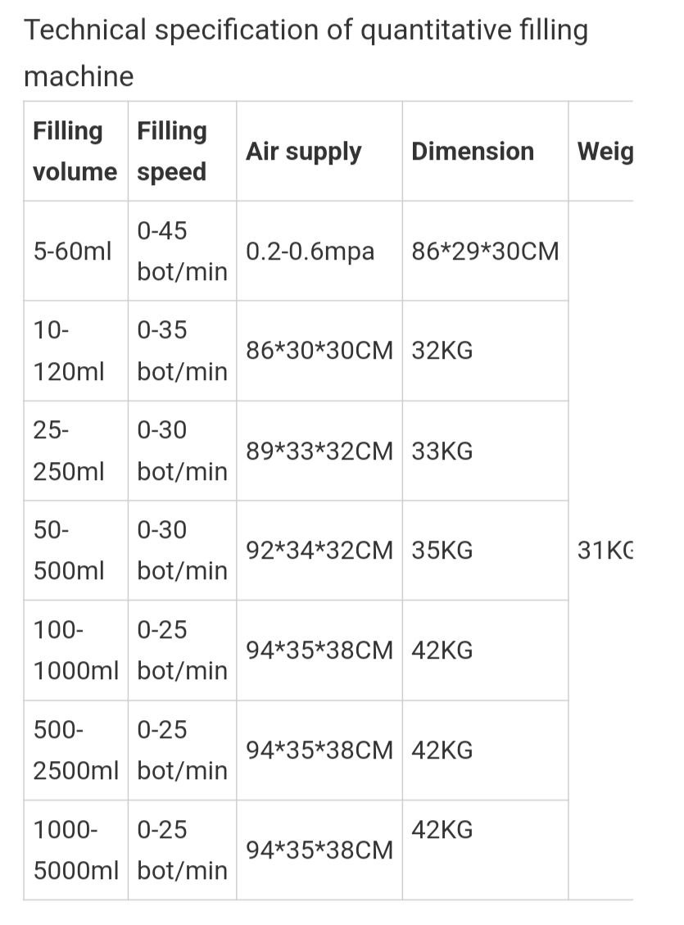
Q max:
The highest flow is 250 ml and the maximum is 30 bottles per minute:
$$Q=\frac{V}{t}=\frac{250*30}{60}=125 ml\backslash s$$

Q min:
The minimum flow is 25 ml and the maximum is 45 bottles per minute:
$$Q=\frac{V}{t}=\frac{25*45}{60}=18.75 ml\backslash s$$

ΔQ=Q max −Q min=125-18.75=106.25 ml\s

6. Filling Mass
The mass depends on the density of the packed material.
law:
m= ρ × V (Esposito, 2014)
where:
m: mass (kg)
ρ: density of material (kg/m³)
V: Volume (m³)
Data Provide:
V: 250 ml=250 *10^-6 =0.00025 m³
ρ:1.170 kg/m³

m =1.170*0.00025=0.2925 g

5. Safety measures:

- Periodic inspection of bases and screws
- Ensure that the machine is level
- Monitor any abnormal vibrations
- Ensure that there are no cracks in the floor (Clevelandequipment, 2024)

6. Additional recommendations:

- Use anti-vibration rubber pads
- Install a level on the machine
- Leave sufficient space around the machine for maintenance
- Provide a drainage system for spilled liquids

These measures ensure:
- Stability of the machine during operation
- Safety of operation
- Ease of maintenance
- Longer operating life of the machine

Important notes:
- Honey constitutes the largest weight due to its high density
- The maximum weight (89.5 kg) must be taken into account when designing the mounting bases
- The floor load-bearing capacity must be determined based on the maximum weight
- The operating system must withstand the additional pressure of high-density liquids

3. Engineering Drawings:
- Body Dimensions: 137.3×45.7×49.2 cm
- Tank Dimensions: 45×45×45 cm
- Drawing filling machine (Solidprize, 2019):
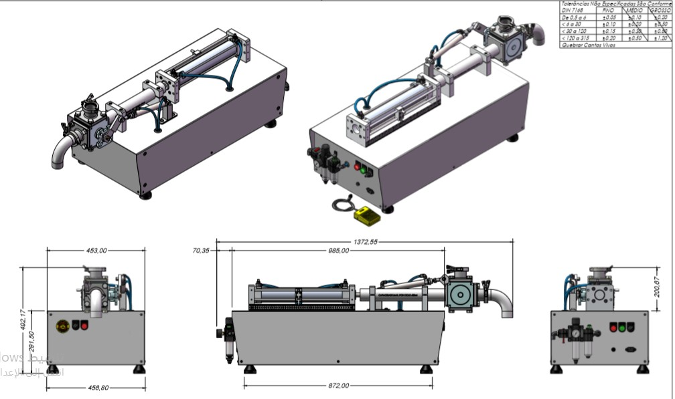
Figure 1:filling machine daigram

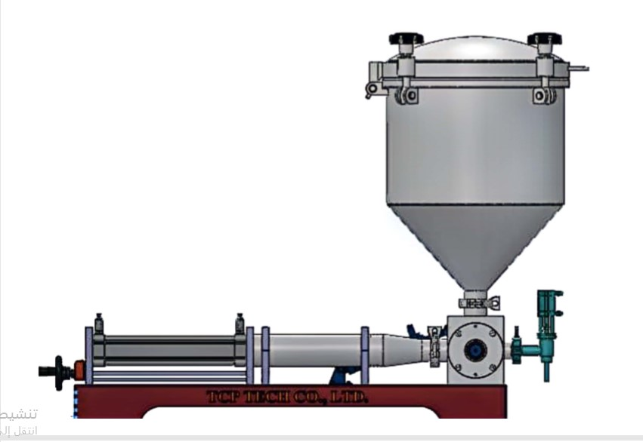
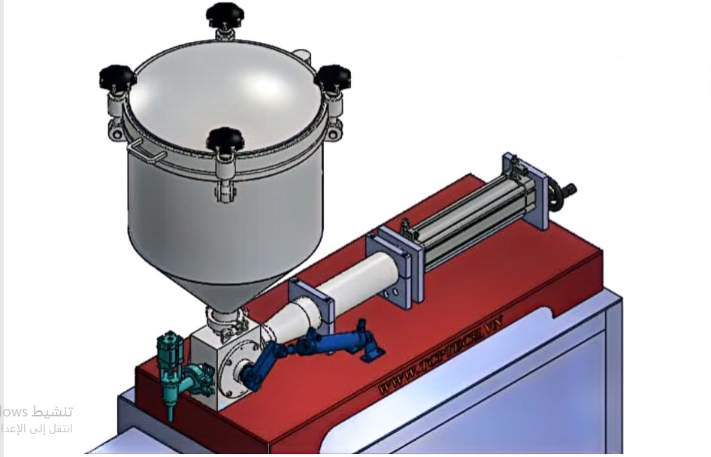
Drawing filling machine in SolidWorks (GradCAD, 2023):
Figure 2: front veiw
Figure 3:top veiw

1-4 Working Principle
The cylinder runs in reciprocating and linear manners to drive the piston and generate suction and thrust so as to draw and push your product (Clevelandequipment, 2024).

Working Process
Open the inlet valve, adjust the working air pressure and select the working status (automatic or semiautomatic). During the operation, the rotary cylinder linkage is turned (opens a path towards the front while sealing towards the top), the fill head cylinder moves upwards to open the discharge valve, the piston cylinder actuates to move the piston forward, which dispenses material for filling ( the speed can be adjusted by the “Behind” valve); after that, the fill head cylinder moves downwards to close the discharge valve to prevent dripping, the rotary cylinder linkage returns (seals towards the front while opening a path towards the top), the piston cylinder actuates to move the piston rearward, which pulls new product into the chamber for the next filling (speed can be adjusted by the “Front” valve). Thus, the operation is accomplished (Clevelandequipment, 2024)

Available Range
It is ideal for special industries such as food, daily chemistry, pesticide and medication (Clevelandequipment, 2024) (filling machine, 2018).

5. Design Analysis:
- Cost Analysis: Material and manufacturing cost:
Part name | Amount | Price | Picture
filling nozzle 25*35 | 1 | 200$ | 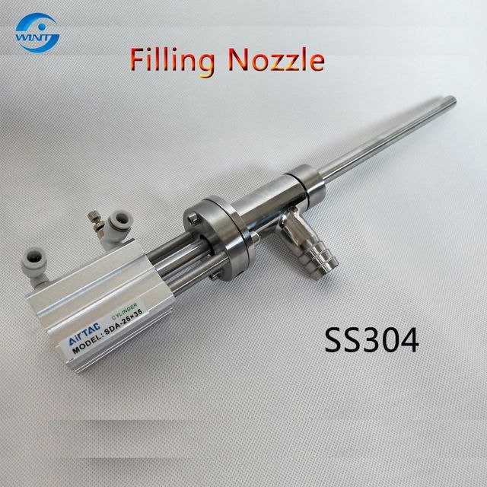
Rotary valve 38 mm (with piston) | 1 | 400$ | 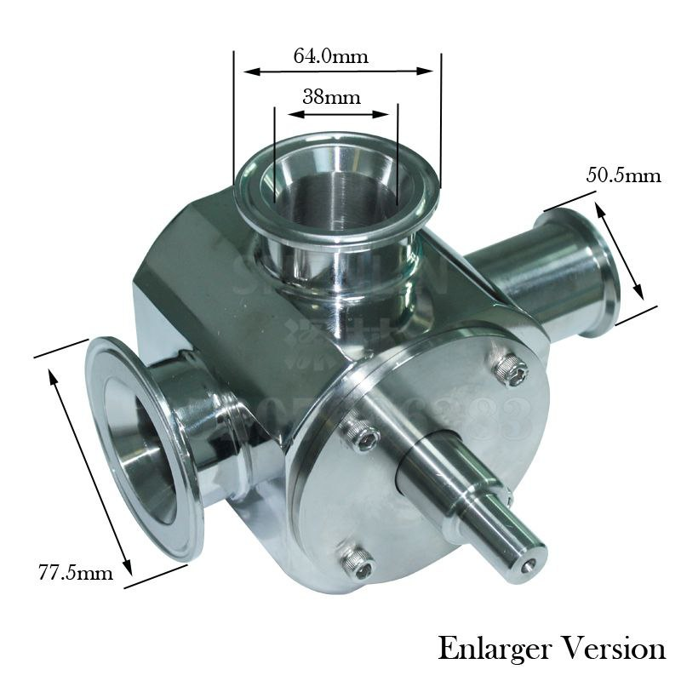
Cylinder su50*200s | 1 | 200$ | 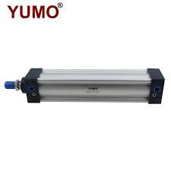
Mini cylinder | 1 | 80$ | 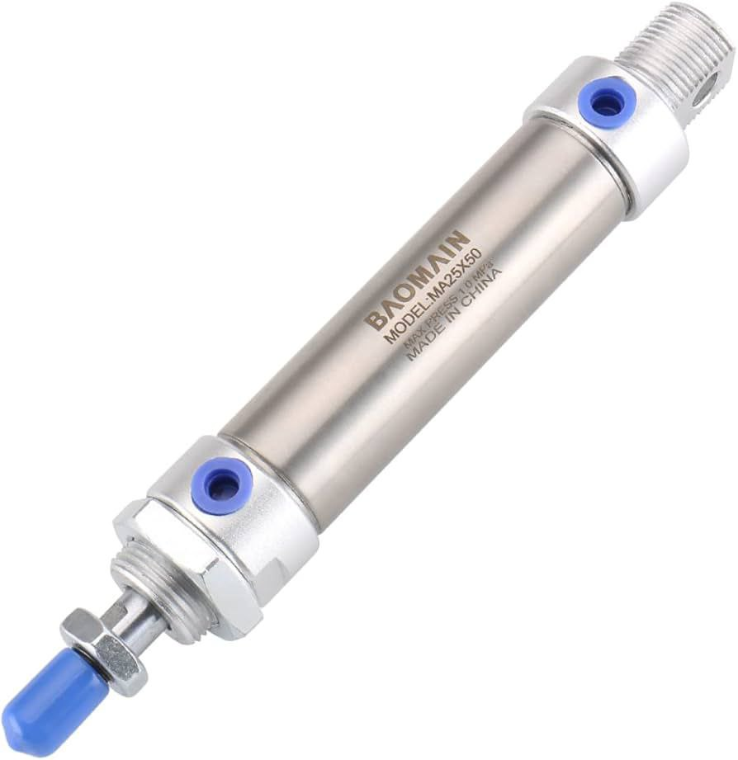
Fixing ring  (77.5mm-64mm-50.5mm) | 3 | 30$ | 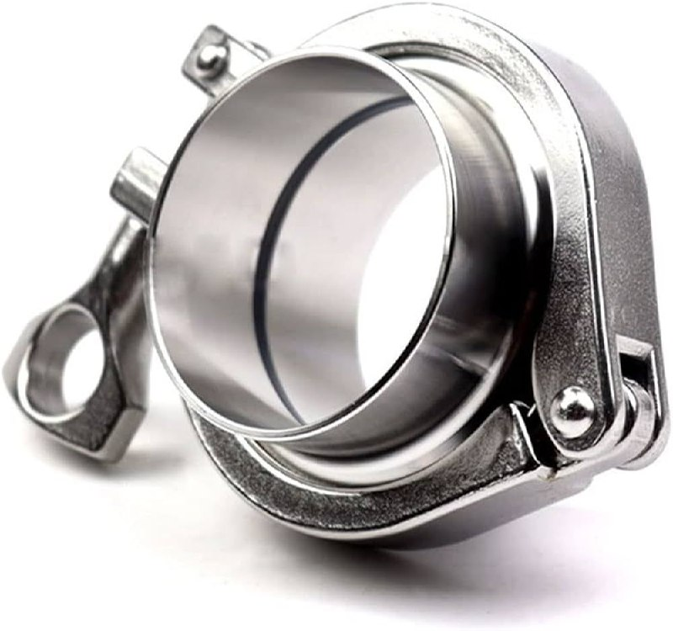
Barometer | 1 | 80$ | 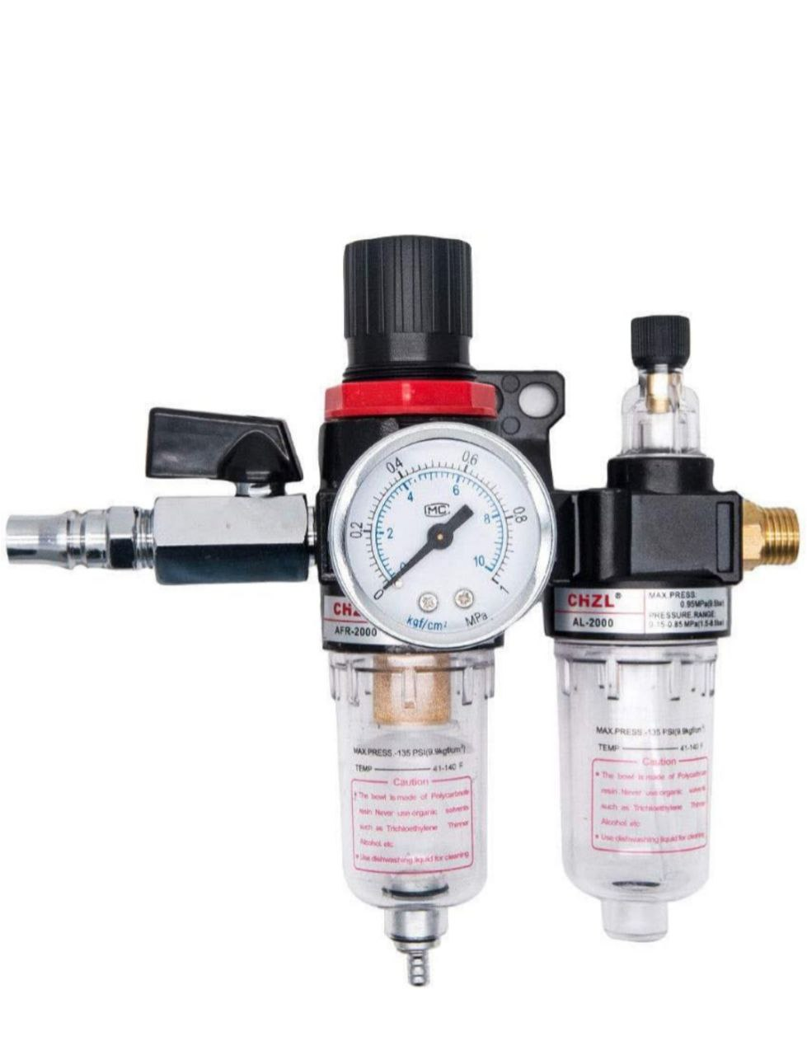
hopper | 1 | 200$ | 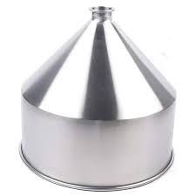
Spare parts for packing | 1 | 30.000 YR | 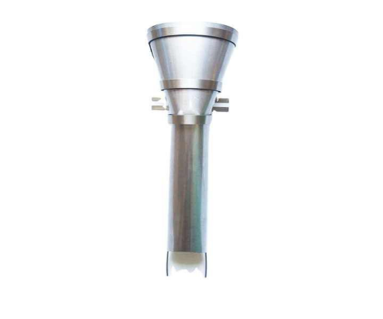

Introduction to Parts and Specifications
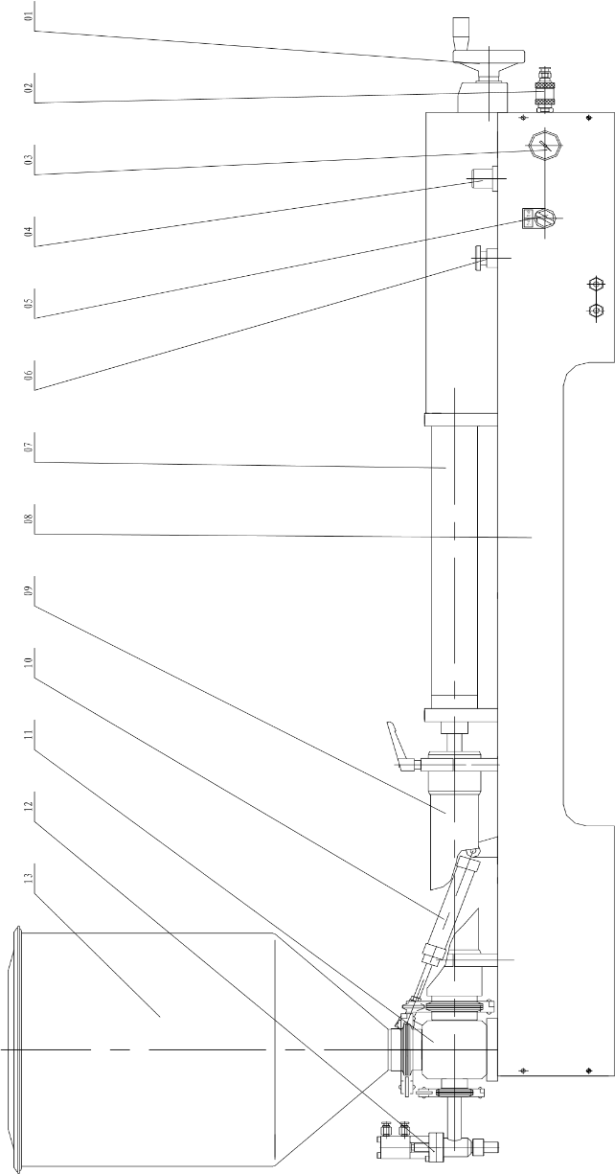
Figure 4:components

Hand wheel
2. Air source switch
3. Plate-type manometer
4. Regulating filter
5. Selection switch
6. Reset switch
7. Cylinder
8. Machine body
9. Cylinder for Material
10. Mini-cylinder
11. Valve body
12. Filing nozzle
13. Charging basket (filling machine, 2018)
Explanation of the parts used:
- cylinder(su50*200s):
Choosing the right components for a system is crucial for optimal performance and efficiency. This report outlines the considerations and steps involved in selecting parts based on specific needs, using the provided specification table as a reference.
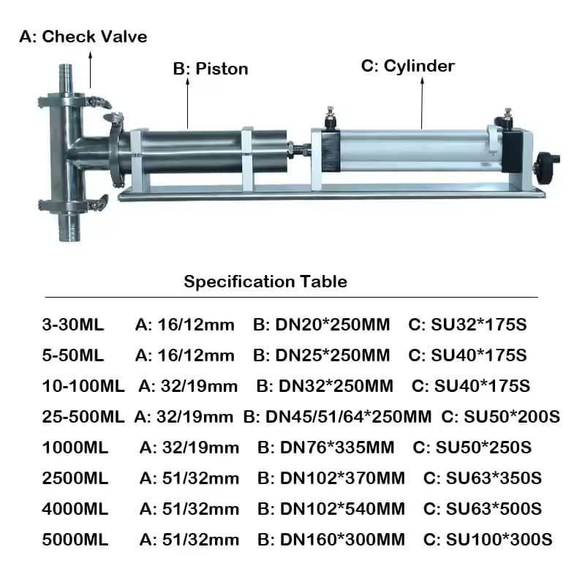
We chose the SU50*200S because it meets the need for filling from 25ml to 500ml and is capable of pumping without any failure in the process.
Datasheet:
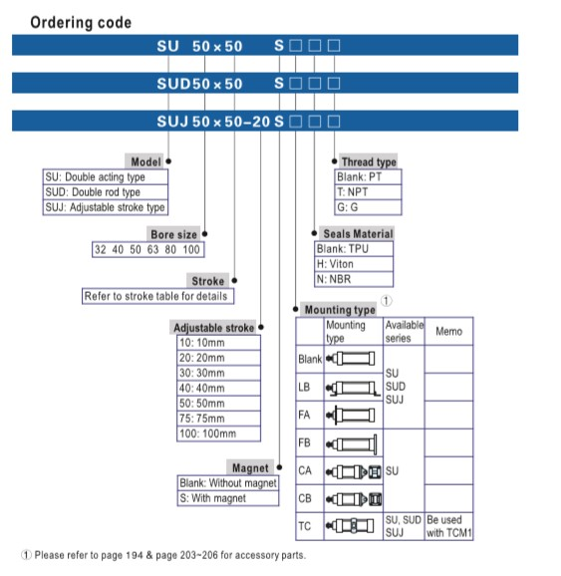
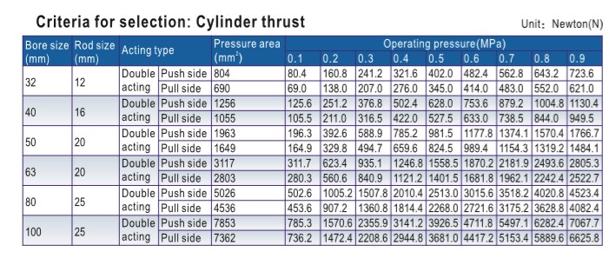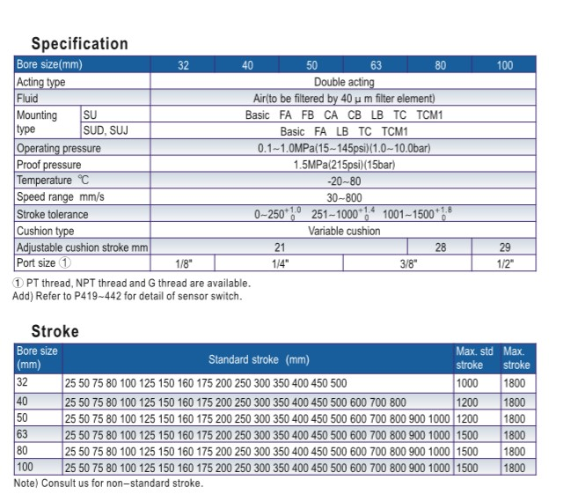

1. Dimensions
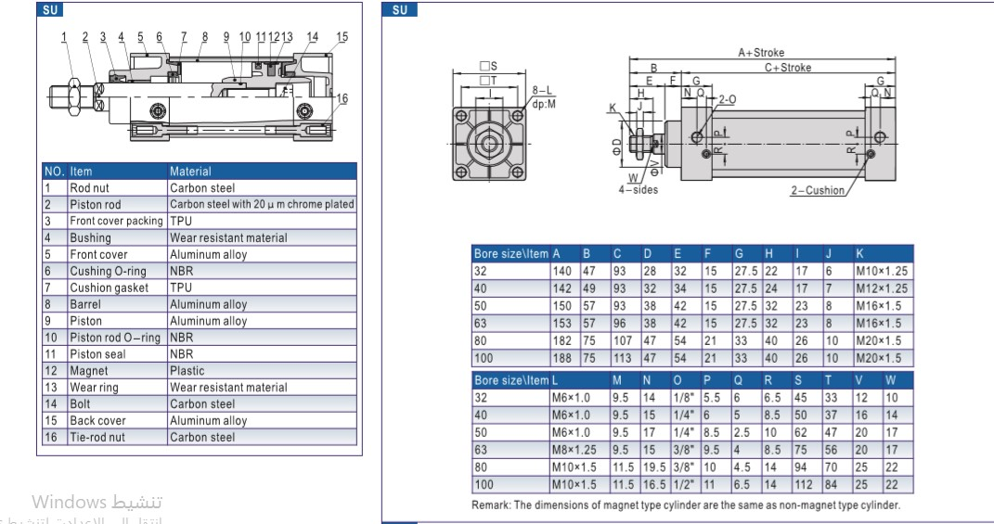
When selecting parts, the following factors should be considered:
1. Flow Rate Requirements
- Identify the required flow rate for the application. The specification table provides flow rates from 3-30 mL to 25,000 mL.
- Choose a part that can handle the desired flow without causing pressure drops or inefficiencies.
2. Size Compatibility
- Ensure that the dimensions of the components fit within the physical constraints of the system. The specifications include various diameters and lengths (e.g., DN16, DN20, DN32).
- Check compatibility with existing connections and fittings.
3. Operating Pressure
- Verify the operating pressure for the application. Ensure that the selected components can withstand the pressure conditions without failure.

2.mini cylinder (MAC32*75):

Reasons for Choosing the MAC32*75 Mini Cylinder
1. Compact Design: The MAC32*75 mini cylinder has a small footprint, making it ideal for applications with limited space.
2. Double Action Functionality: This cylinder operates in both directions, providing versatility in various mechanical systems.
3. Adjustable Buffer: The adjustable buffer feature allows for fine-tuning of the cylinder's cushioning, enhancing performance and reducing wear.
4. Wide Operating Pressure Range: With a pressure range of 0.1 to 0.8 MPa, it can accommodate different operational requirements.
5. Durability: The materials used in the construction of the MAC32*75 ensure longevity and resistance to wear and tear.
6. Temperature Resilience: It can operate in a variety of temperatures, making it suitable for different environments.
7. Easy Installation: Its design facilitates straightforward installation and integration into existing systems.
8. Reliable Performance: The cylinder is designed for consistent and reliable operation, reducing downtime and maintenance needs.
Datasheet:
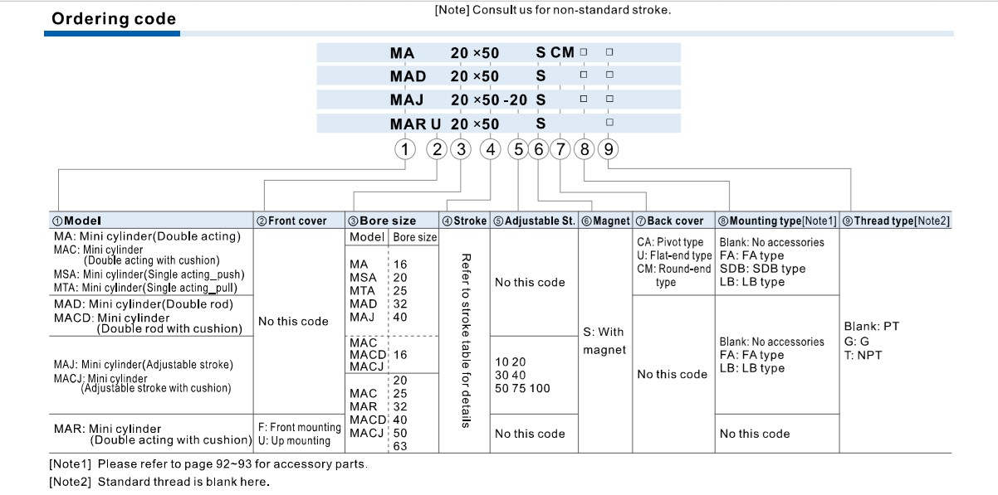
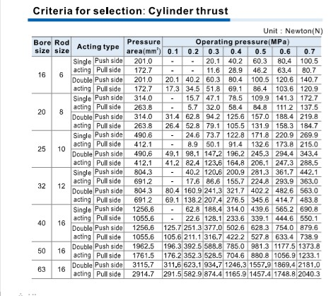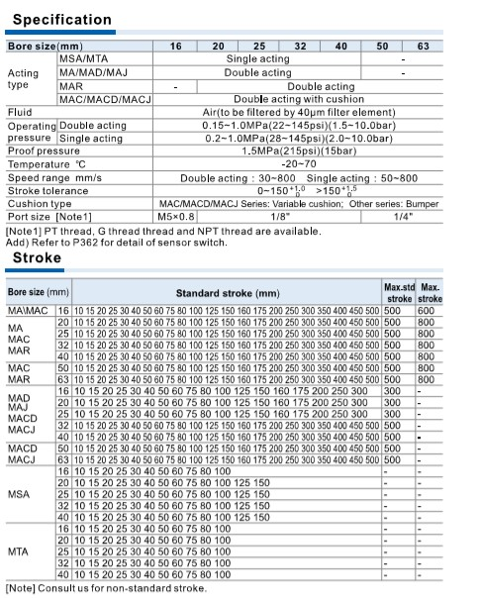

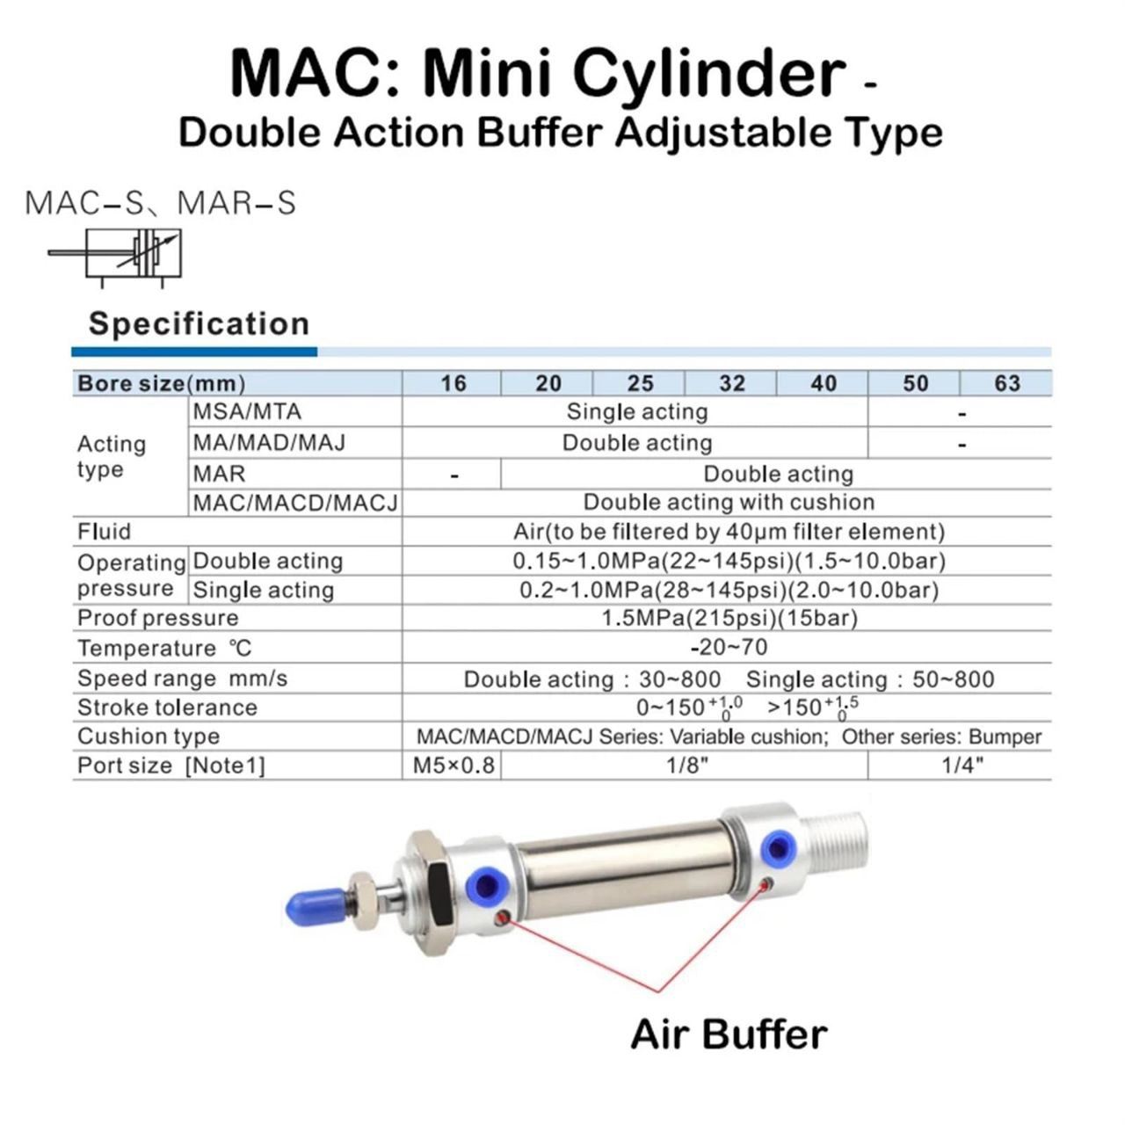

Product Overview:
The MAC Mini Cylinder is a double-action buffer adjustable type, designed for various applications requiring precise control and efficiency in pneumatic systems.
Specifications:
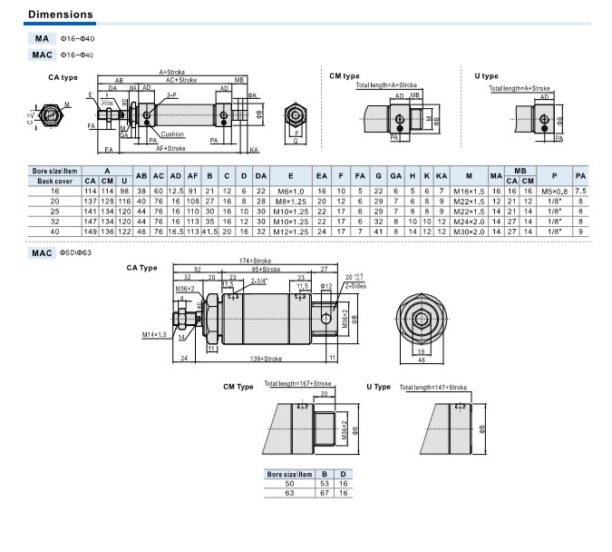
- Bore Size (mm):16, 20, 25, 32, 40, 50, 63
- Acting Type:
- MSA/MTA: Single acting
- MA/MAD/MAJ: Double acting
- MAR: Double acting
- MAC/MACD/MACJ: Double acting

Performance Characteristics:
- Operating Pressure:
- Standard: 0.1 - 0.8 MPa (14.5 - 116 psi)
- Maximum: 1.0 MPa (145 psi)

- Temperature Range:
- Operating Temperature: 0°C to 60°C

Design Features:
- Equipped with an air buffer for enhanced performance.
- Adjustable cushion type for better control during operation.
3. piston(250mm*45):
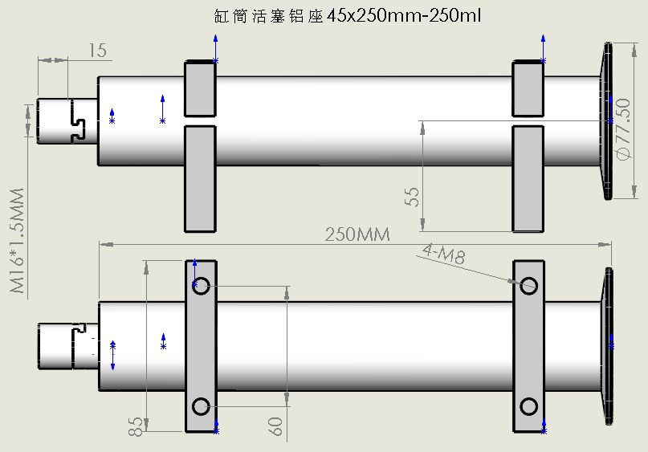
The piston design was chosen to fill 250 ml, and the appropriate dimensions were chosen that are compatible with the filling machine and can withstand a cylinder pressure of about 0.6MPa.

Key Features:

1. Dimensions
- Diameter: 45 mm
- Length: 250 mm
- These measurements help in determining the cylinder's capacity and compatibility with other system components.

4. roll valve:
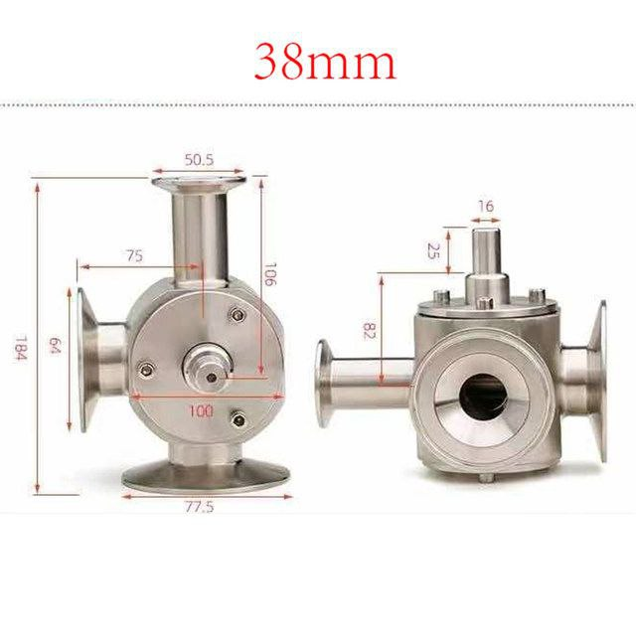
Overview:

The image depicts a 38 mm valve, likely a type of check valve or flow control valve used in various fluid systems. This specific valve is designed to regulate the flow of liquids or gases, preventing backflow and ensuring smooth operation.
Working Principle:
- In the home position, the outlet is closed and the hopper is open with the piston, so that the piston pulls the raw material from the hopper to the piston.
- In the run position, the hopper is closed and the outlet is opened so that the piston is connected to the outlet and the raw material is pushed from the piston to the outlet.
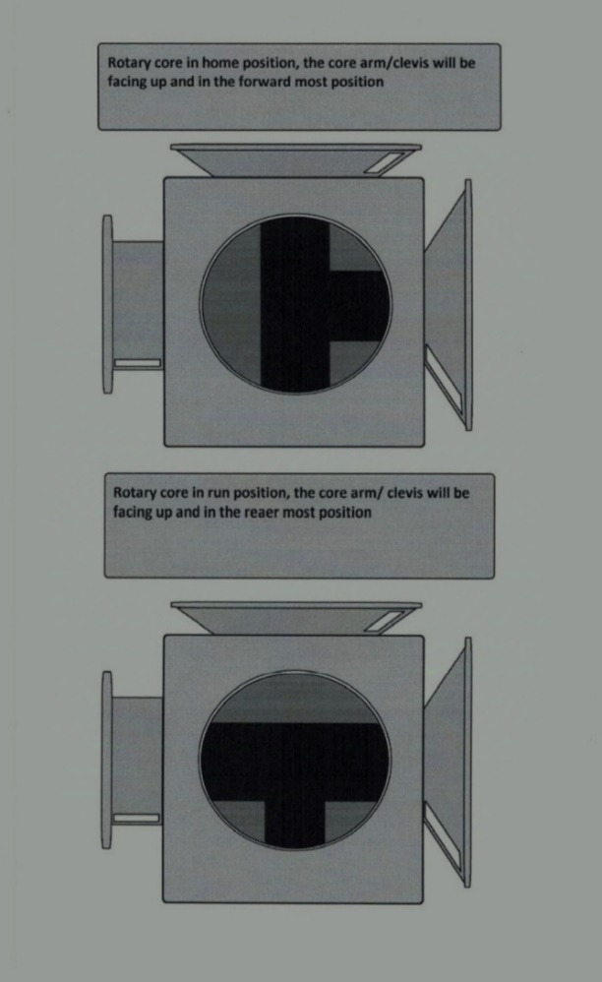
Key Features:
1. Dimensions
- Diameter: 38 mm
- Length and Height: Specific measurements are provided (e.g., 106 mm, 64 mm), indicating the size of the valve and how it will fit within a system.

2. Material
- The valve appears to be made of stainless steel, which offers durability, corrosion resistance, and suitability for a variety of applications, including food processing, pharmaceuticals, and chemical handling.

3. Inlet and Outlet Ports
- The valve has two ports for fluid entry and exit, indicated by the flanges on either side. This design allows for easy installation and integration into piping systems.

4. Flow Direction
- As a valve, it likely has a specific flow direction indicated by the design, ensuring that fluid flows in one direction and preventing backflow.

5. Connection Type
- The flanged ends suggest that the valve can be easily connected to existing piping systems using bolts, providing a secure and leak-proof connection.

Applications:

- Fluid Control: Used in various industries to manage the flow of liquids and gases.
- Preventing Backflow: Protects systems from contamination and pressure fluctuations by stopping reverse flow.
- Pneumatic and Hydraulic Systems: Commonly used in systems requiring precise flow control.

4. hopper:
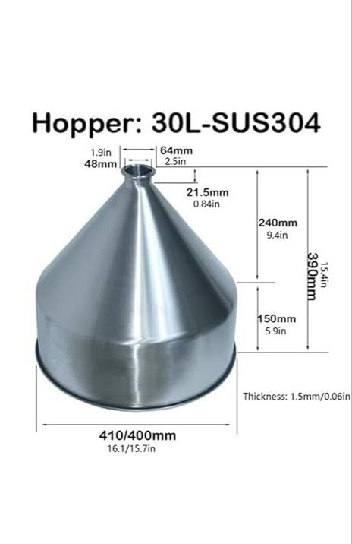

5. filling nozzle:
The filling nozzle is with anti-dripping function, ensure the filling accuracy and production quality. It is made of 304 stainless steel, which is meet the food grade requirements.

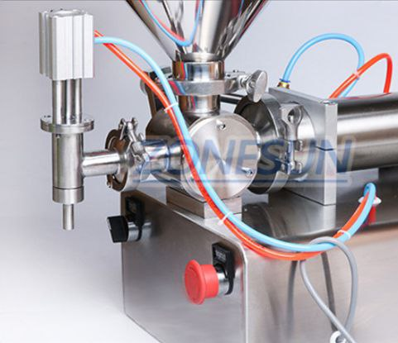

- Dimensions:
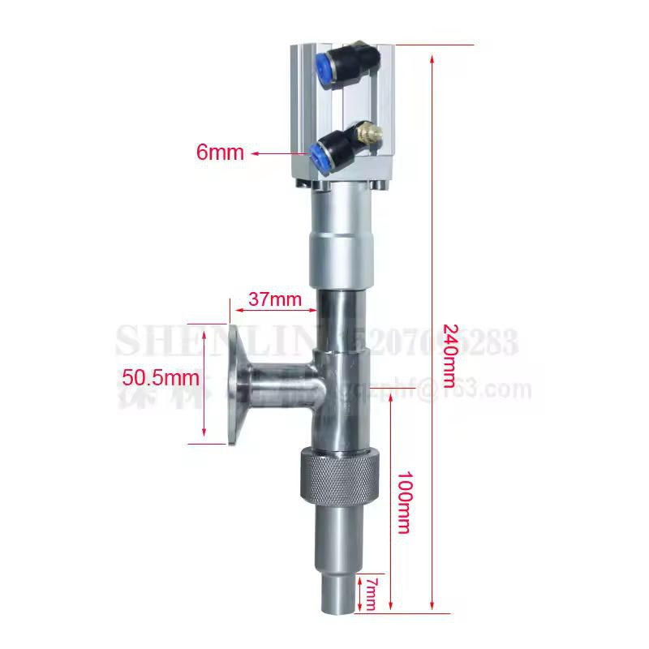

6. Filling speed:
The filling speed and waiting time can be adjusted, rotate knobs clockwise to slow down working speed. If you use the automatic working mode, please lengthen the waiting time to make the machine works better.

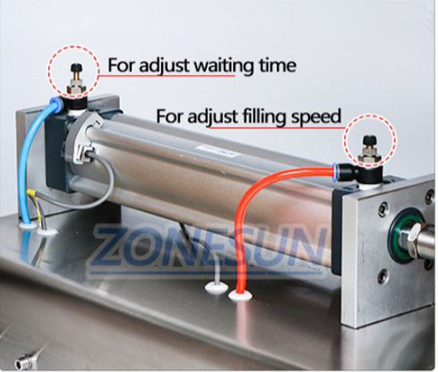

7. rotary knob:
The larger rotary knob is designed for controlling the filling range, make it easier to operate and adjust the machine.
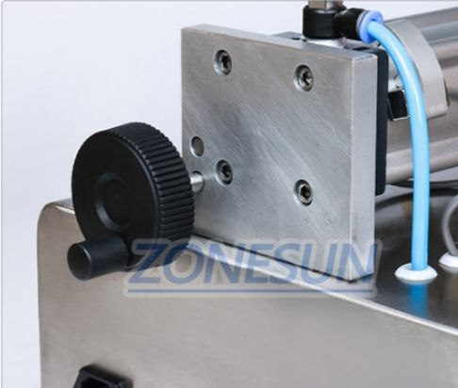

- Barometer:
The barometer can be used to watch air pressure in real time, ensure the safety operation, This machine should work with the air compressor, customers need to but it separately. If you
need this please contact us.
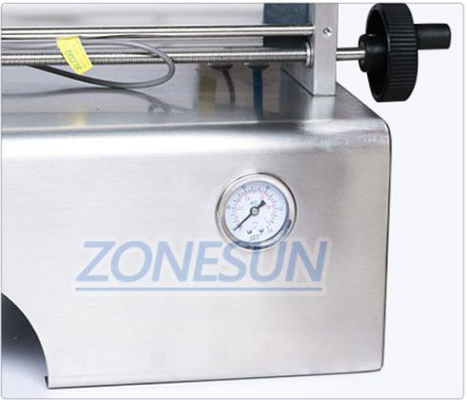

The dimensions of the hopper were chosen to accommodate 30 liters to place the raw material, and the material is drawn through a rotary valve to the piston.

Components cylinder:

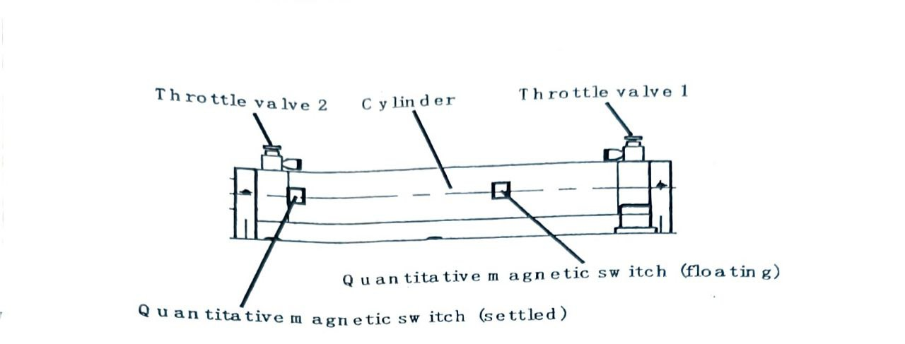

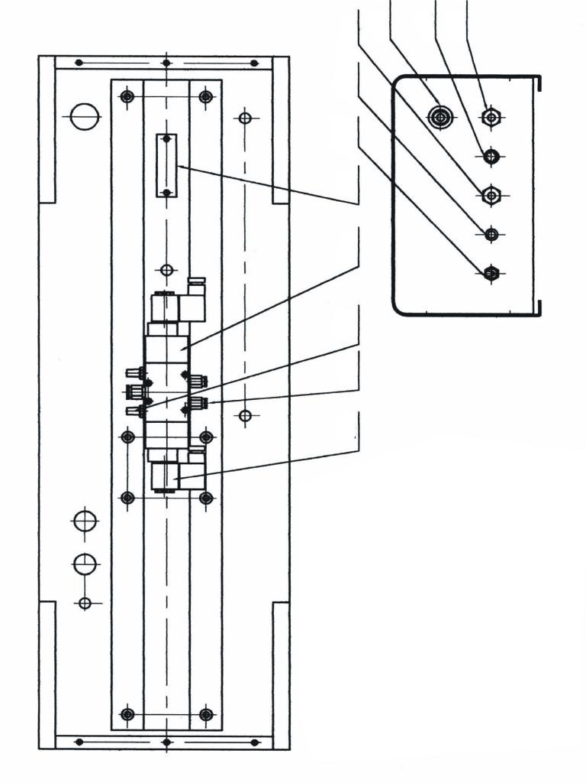

19. Cable connector 27. Silencer
20. Fuse holder 28. Straightway valve
21. Air source switch 29.coil
22. Cable connector (connected to pedal switch)
23. Crawl switch (choose)
24. Power switch
25. Terminals
26. Solenoid (two-position five way) (filling machine, 2018)

(.Mccormac, 2010) Part The Nozzle Discharge (Thapar University, 2020):

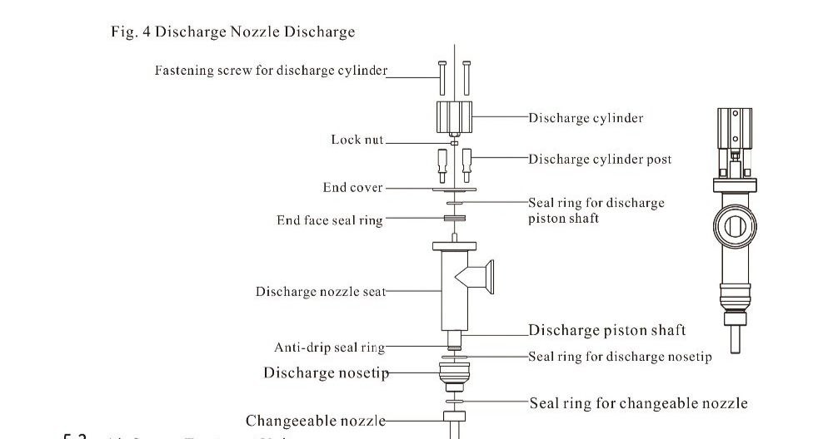

Materials used:
Stainless steel 304
How to design a hopper:
1. Determine the dimensions:
- We Start by determining the required dimensions for each funnel based on the required capacity (10L, 30L, 50L) and the diameter of the funnel (50mm, 64mm).
- You must calculate the dimensions accurately, including the height, diameter and thickness.

2. Selection of materials:
- Use suitable materials such as stainless steel (SUS304) to ensure durability and corrosion resistance.
- Make sure that the thickness of the material is suitable for your applications (such as 1.5mm).

3. Design the funnel:
- Use engineering design programs such as AutoCAD or SolidWorks to create a 3D model.
- Design the shape in a funnel shape, with a circular base and a pointed top.
- Make sure that the base is flat to facilitate installation on surfaces.

CAD design of hopper:

Types of hoppers with measurements (Amazon, 2024):
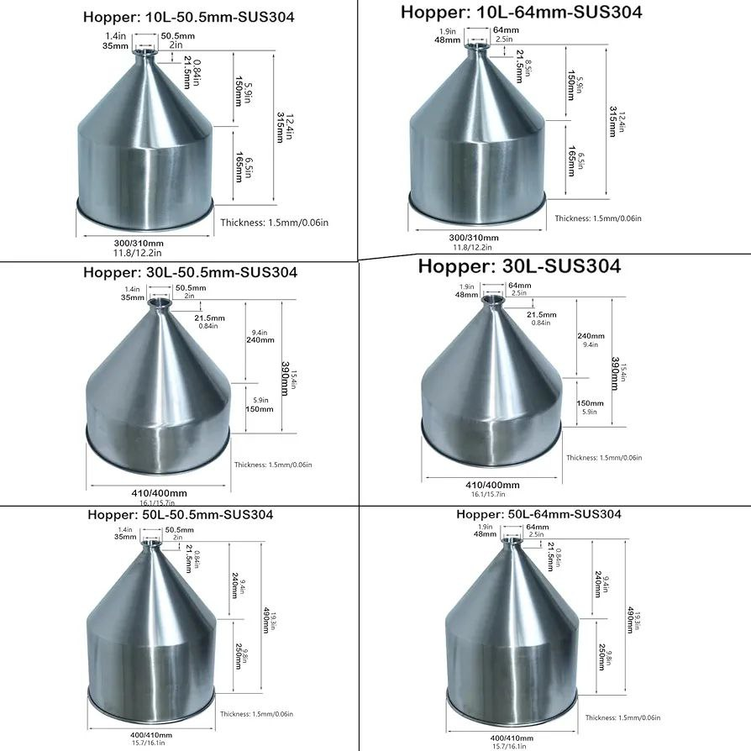

4. Structural Analysis (Thapar University, 2020):
- Structural analysis to ensure that the funnel can withstand the required weight and pressure.
- Verify that the design complies with local standards and regulations.
The relationship between the angle and outlet dimension:
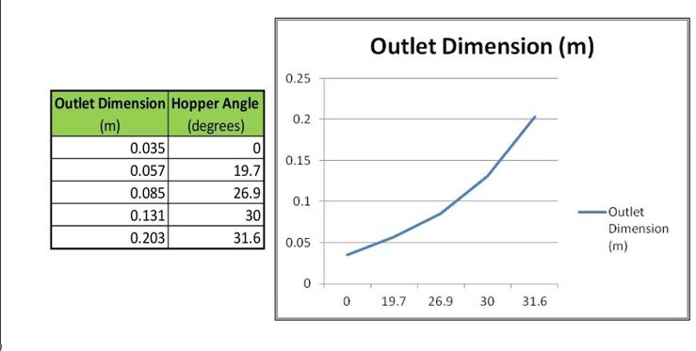
Hopper stress study in SolidWorks:
For epoxy:
1. Introduction
This report presents the finite element analysis (FEA) results of a hopper structure under static loading conditions. Three main analyses were performed: stress analysis (von Mises), strain analysis (ESTRN), and displacement analysis (URES).

3. Results Analysis
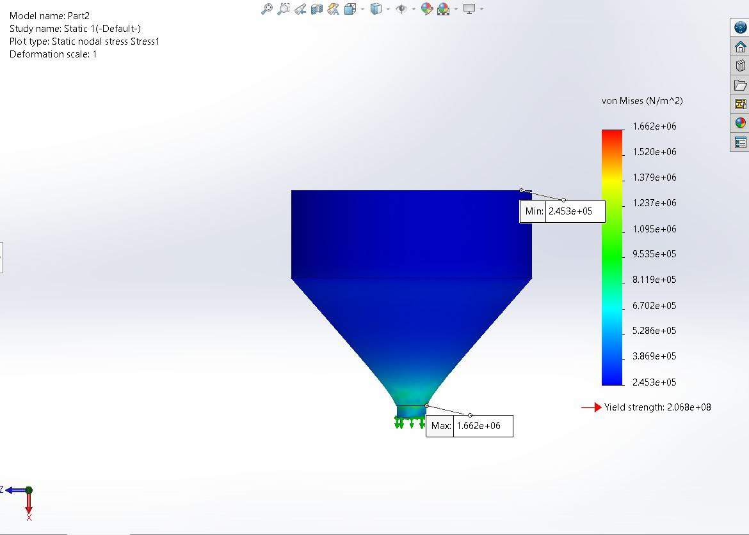
3.1 Stress Analysis (von Mises)
- Maximum stress: 1.662 MPa
- Minimum stress: 0.2453 MPa
- Yield strength: 2.068e+08 N/m²
- Safety factor: The maximum stress is significantly below the yield strength, indicating a safe design
- Stress concentration: Highest at the bottom discharge area
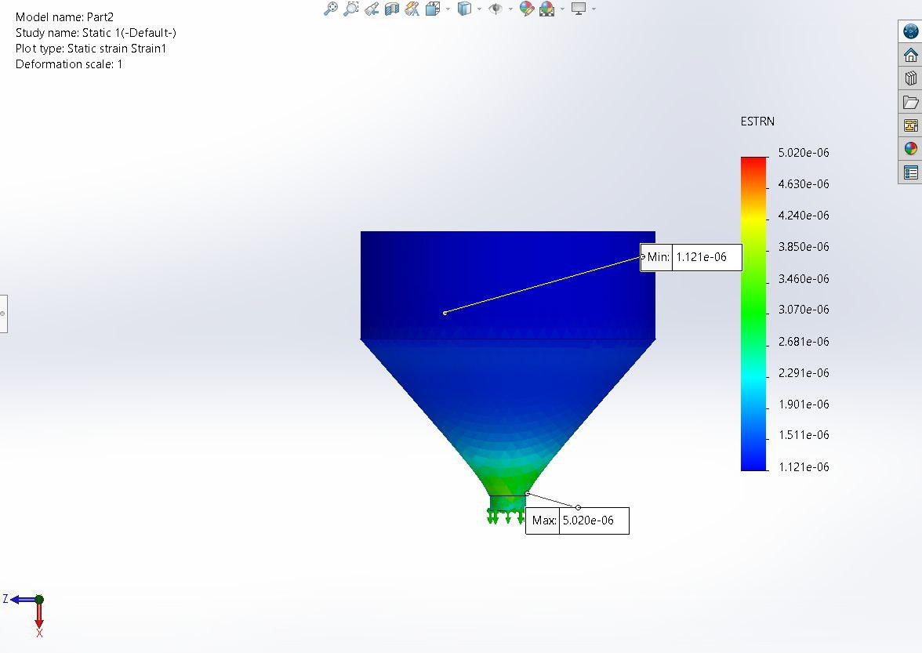
3.2 Strain Analysis (ESTRN)
- Maximum strain: 5.020e-06
- Minimum strain: 1.121e-06
- Distribution pattern: Gradual increase from top to bottom
- Highest strain concentration: Bottom discharge section
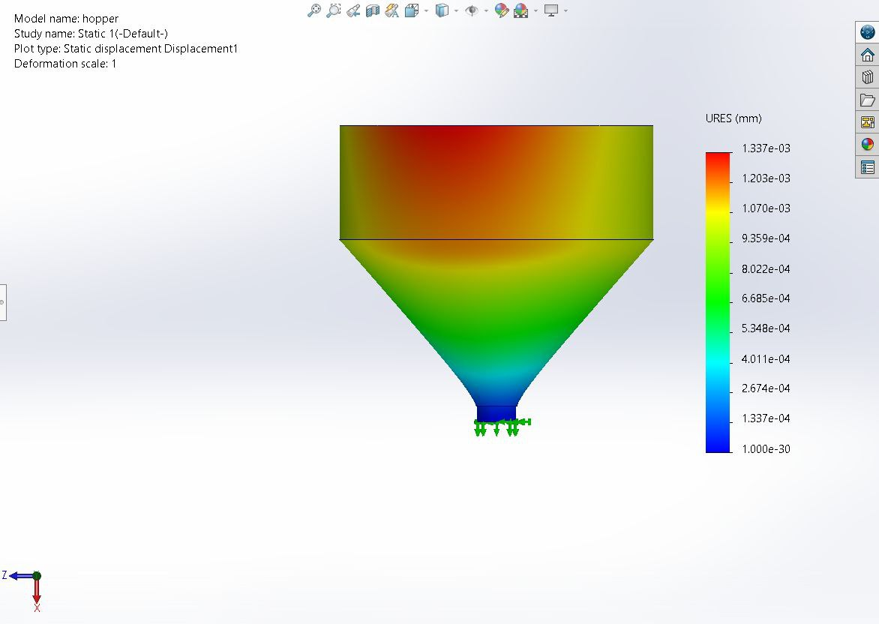
3.3 Displacement Analysis (URES)
- Maximum displacement: 1.337e-03 mm
- Minimum displacement: ~0 mm (fixed supports)
- Displacement pattern: Highest at the top section
- Color gradient shows progressive deformation from bottom to top

4. Discussion
4.1 Structural Integrity
- The hopper design shows excellent structural integrity
- Maximum stress is well below the yield strength, providing a large safety margin
- Strain values are minimal, indicating elastic deformation only

4.2 Critical Areas
- Bottom discharge area shows stress concentration
- Top section experiences maximum displacement
- Transition zone between vertical and inclined surfaces shows moderate stress distribution

4.3 Performance Evaluation
- The design is structurally sound for static loading conditions
- Deformations are negligible and within acceptable limits
- Stress distribution pattern is favorable for the intended application

6. Conclusion
The simulation results demonstrate that the hopper design is structurally adequate for the intended loading conditions. All analyzed parameters (stress, strain, and displacement) are within safe limits, indicating a robust design with sufficient safety margins
The design can be considered optimized as it maintains structural integrity while minimizing material usage, as evidenced by the uniform stress distribution pattern and minimal deformation characteristics.
For honey:
1. Introduction
This report presents the finite element analysis (FEA) results of a hopper structure under static loading conditions. Three main analyses were performed: stress analysis (von Mises), strain analysis (ESTRN), and displacement analysis (URES). The results are evaluated to assess the structural integrity, identify critical areas, and provide recommendations for design optimization.
3. Results Analysis
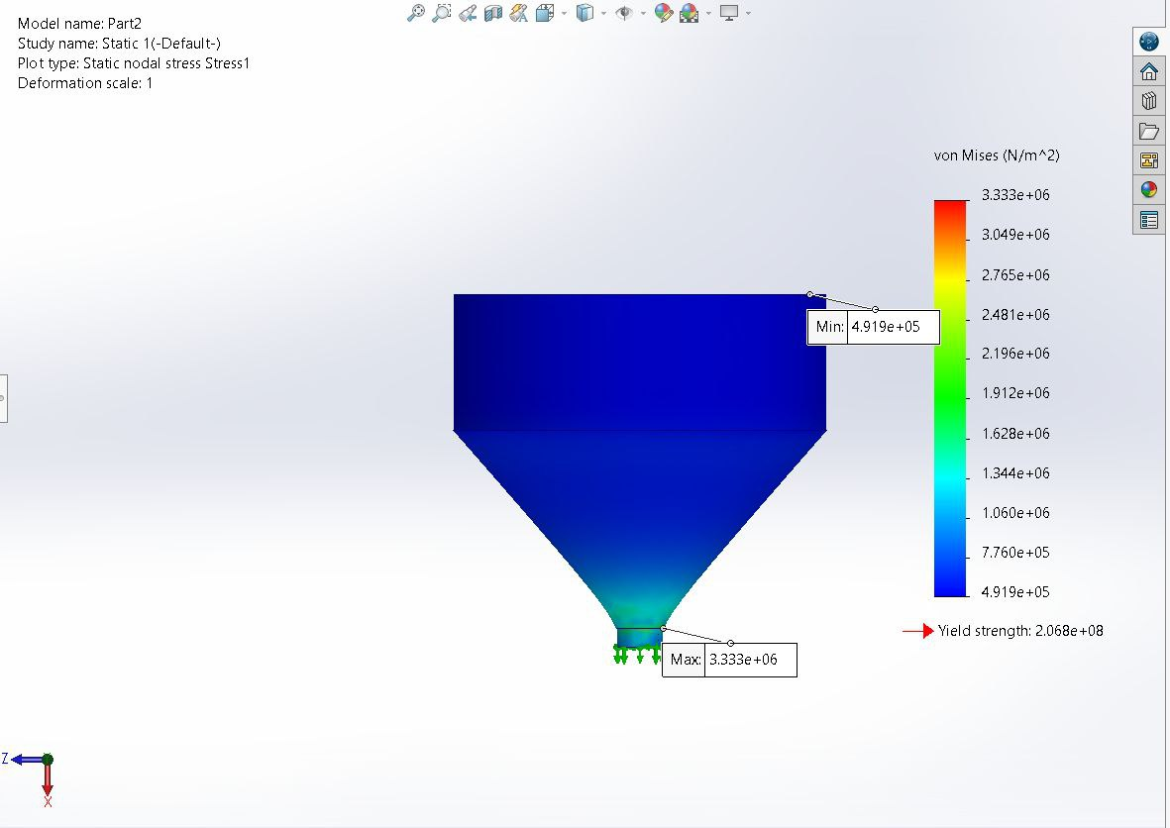
3.1 Stress Analysis (von Mises)
- Maximum stress: 3.333 MPa
- Minimum stress: 0.4919 MPa
- Yield strength: 2.068e+08 N/m²
- Safety factor: The maximum stress is significantly below the yield strength, indicating a safe design.
- Stress concentration: Highest at the bottom discharge area.
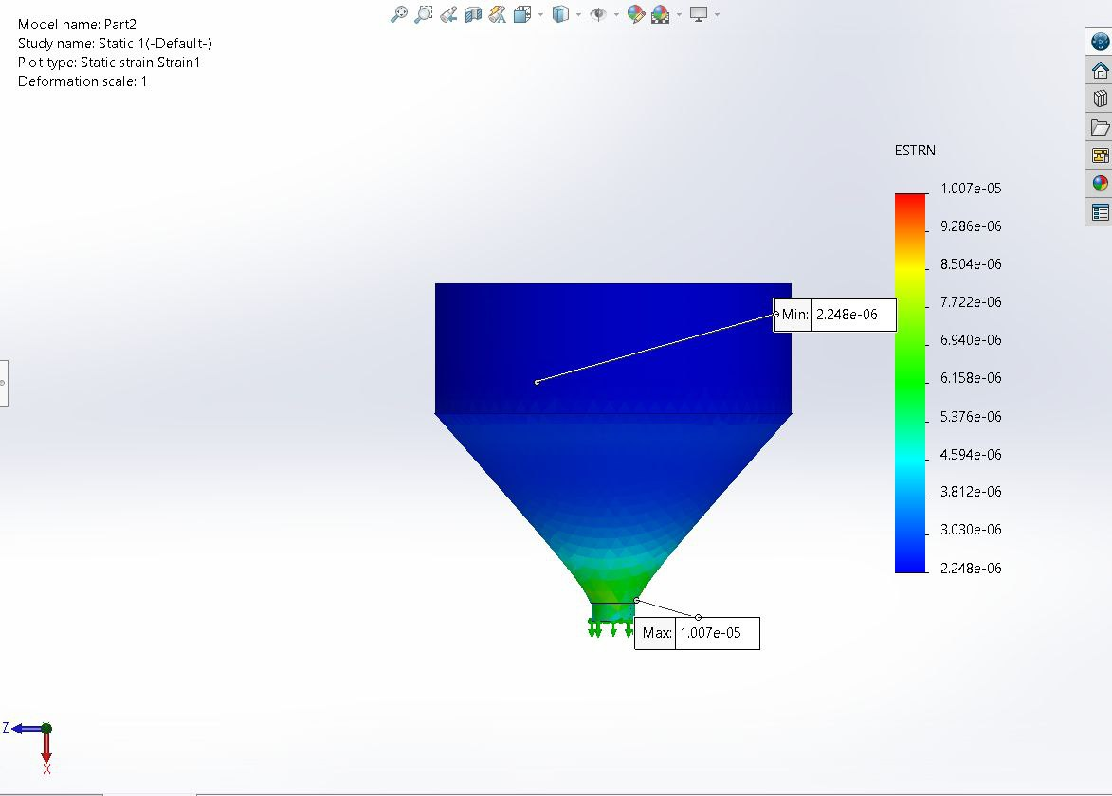
3.2 Strain Analysis (ESTRN)
- Maximum strain: 1.007e-05
- Minimum strain: 2.248e-06
- Distribution pattern: Gradual increase from top to bottom.
- Highest strain concentration: Bottom discharge section.
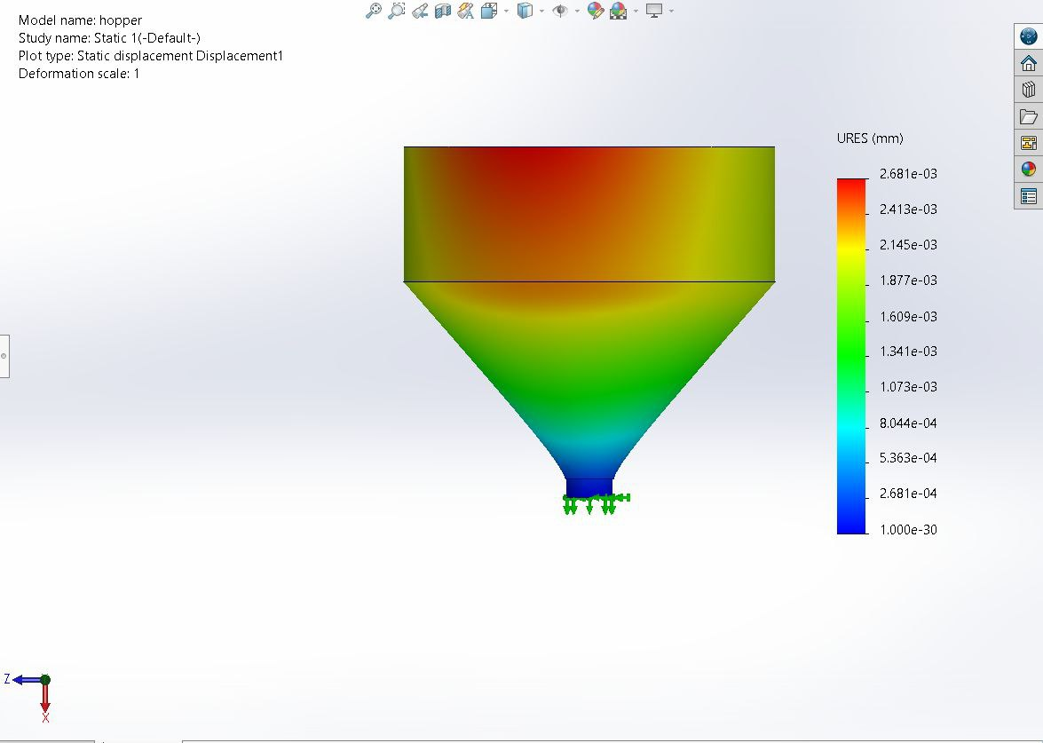
3.3 Displacement Analysis (URES)
- Maximum displacement: 2.681e-03 mm
- Minimum displacement: ~0 mm (fixed supports).
- Displacement pattern: Highest at the top section.
- Color gradient: Shows progressive deformation from bottom to top.
4. Discussion

4.1 Structural Integrity
- The hopper design demonstrates excellent structural integrity.
- The maximum stress (3.333 MPa) is well below the material's yield strength (206.8 MPa), providing a large safety margin.
- Strain values are minimal, indicating that the deformation is within the elastic range.
4.2 Critical Areas
- Bottom discharge area: Shows the highest stress concentration, which is typical for such structures due to load distribution.
- Top section: Experiences the maximum displacement, which is expected due to the free movement at the top.
- Transition zone: Between vertical and inclined surfaces, moderate stress distribution is observed, indicating no significant risk of failure.
4.3 Performance Evaluation
- The design is structurally sound for static loading conditions.
- Deformations are negligible and well within acceptable limits.
- The stress distribution pattern is favorable for the intended application, with no excessive localized stresses.
6. Conclusion
The simulation results demonstrate that the hopper design is structurally adequate for the intended static loading conditions. All analyzed parameters (stress, strain, and displacement) are within safe limits, indicating a robust design with sufficient safety margins.
The design is optimized, maintaining structural integrity while minimizing material usage, as evidenced by the uniform stress distribution pattern and minimal deformation characteristics. Further analysis under dynamic conditions is recommended for a comprehensive evaluation.
Design spare filling for packing:
Main components:
1. Main Tube:
- Length: 320mm
- Diameter: about 30-35mm

2. Mounting Bracket:
- Width: 30mm
- Height: 40mm
- Slots: 8.5×45mm

3. Funnel:
- Length: 180mm
- Expansion angle: about 45 degrees
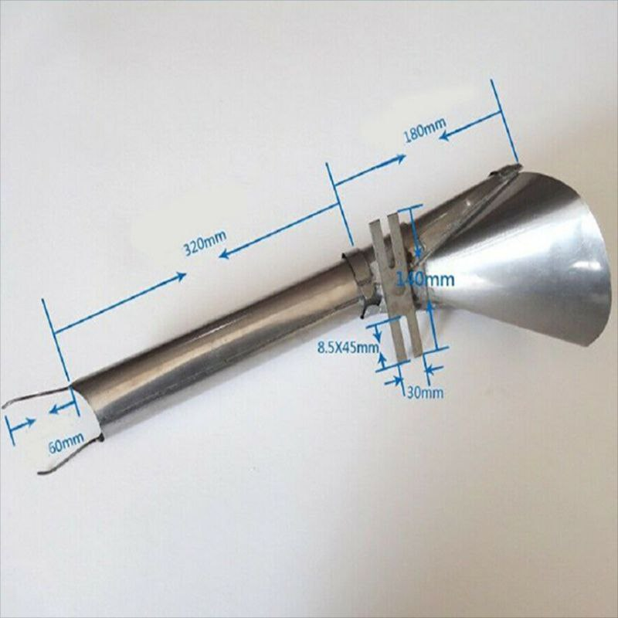

Design Roll holder structure in SolidWorks (GradCAD, 2023):

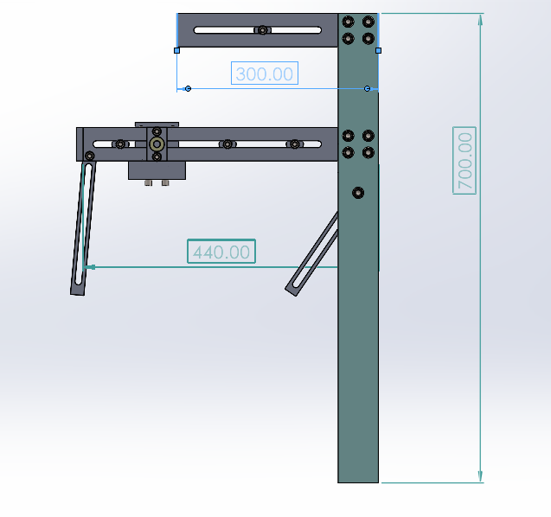

Study stress and strain for top paper roll:
- Strain study:
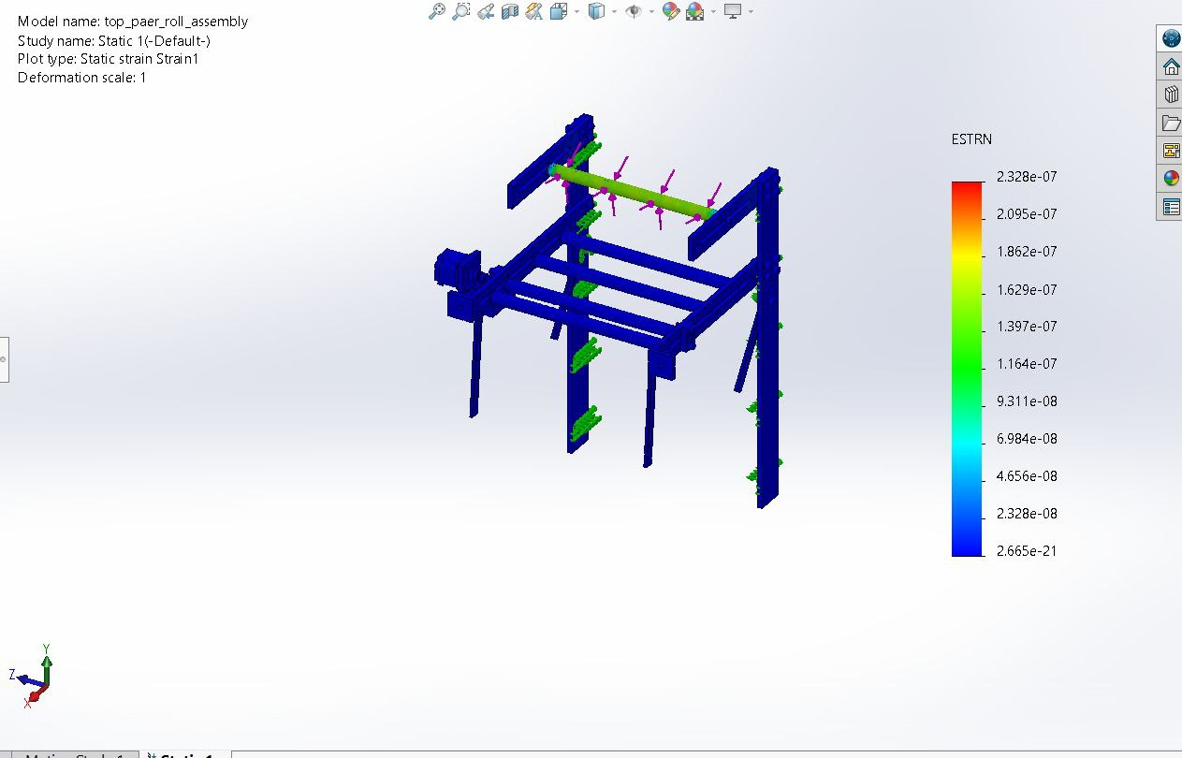
1. MODEL INFORMATION
- The assembly consists of a main frame structure (shown in blue)
- Support brackets and mounting points (visible in green)
- Load application points indicated by pink arrows
- Primary horizontal roll beam

2. ANALYSIS PARAMETERS
Strain Analysis Results:
- Maximum strain: 2.328e-07
- Minimum strain: 2.665e-21
- Scale: Linear color gradient from blue (minimum) to red (maximum)

3. KEY FINDINGS
- The structure shows minimal strain under applied loads
- Highest strain concentrations appear at:
Connection points between horizontal beam and vertical supports
Mounting bracket locations
- Overall structural behavior indicates good stability

4. CONCLUSIONS
- The design demonstrates adequate structural integrity
- Strain values are within acceptable engineering limits
- No critical stress concentrations observed
- The assembly meets static load requirements
2. stress study:
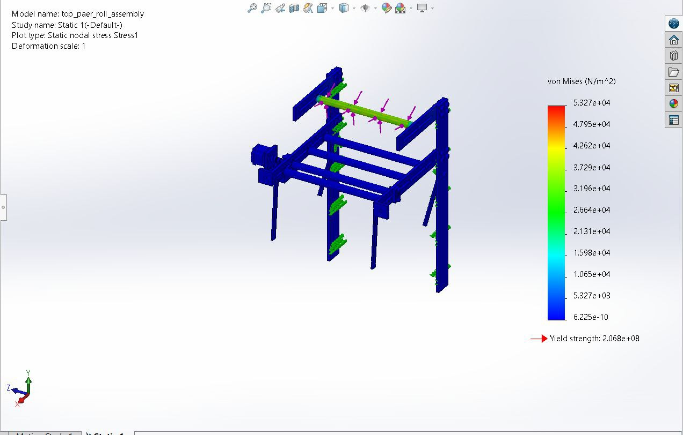
Objective:
The objective of this simulation was to perform a static stress analysis on a structural assembly to evaluate the distribution of stresses under the applied loading conditions and ensure the design's structural integrity against the material's yield strength.

Results and Analysis
1. Stress Distribution
- The von Mises stress plot demonstrates the stress distribution throughout the structure.
- Maximum Stress: 5.327 × 10⁴ N/m², located near the top beam where the load is applied.
- Minimum Stress: Close to 6.225 × 10⁻¹⁰ N/m², observed at areas away from the load and near fixed supports.
- The stress values are well below the material's yield strength, ensuring the structure remains in the elastic deformation range.

2. Deformation
- Deformation Scale: The deformation observed in the simulation is scaled for visualization purposes; actual deformation is minimal.
- No significant displacement is expected under the current loading conditions, indicating the structure's stability.

3. Key Observations
- Critical Areas: Stress concentrations are primarily located at the junctions between the top beam and vertical supports. These areas require careful consideration in the design phase to ensure durability.
- Safety Margin: The maximum stress is significantly lower than the material's yield strength, providing a substantial safety margin.
Conclusion
The static stress analysis confirms that the structural assembly can safely withstand the applied loads without exceeding the material's yield strength. The design is robust and provides a sufficient safety margin, ensuring reliable performance under the specified conditions.
Study flow rate in SolidWorks:
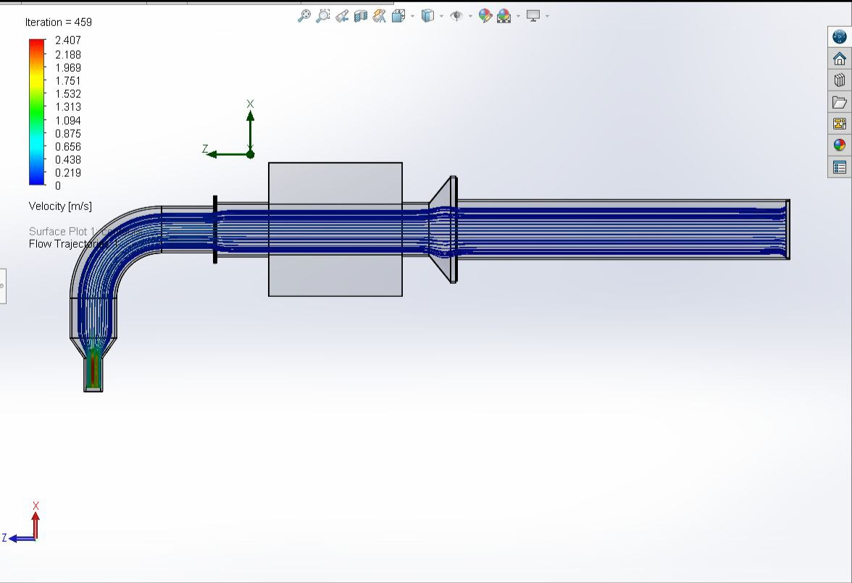
Objective
The objective of this simulation was to analyze the fluid flow behavior through a curved pipe system and evaluate the velocity distribution, flow trajectories, and any potential areas of turbulence or flow inconsistencies.
Results and Analysis
1. Velocity Distribution
- The velocity contours, as shown in the image, indicate a smooth flow entering the pipe.
- At the 90-degree bend, the velocity increases on the outer curve due to the centrifugal effects, while a lower velocity region forms on the inner curve of the bend.
- Maximum velocity observed: 2.407 m/s.
- Minimum velocity observed: 0.219 m/s.

2. Flow Trajectories
- The flow trajectories demonstrate a consistent and streamlined flow pattern throughout the straight sections of the pipe.
- At the bend, flow trajectories deviate slightly, creating regions of recirculation and lower velocity near the inner curve.
- After the bend, the flow realigns and stabilizes as it progresses through the straight section.
3. Key Findings
- High-Velocity Regions: The outer curve of the bend exhibits higher velocities, which may lead to increased shear stresses and potential wear in real-world applications.
- Low-Velocity Zones: Low-velocity regions near the inner curve could result in localized pressure drop or potential buildup of particulates in practical scenarios.
- Flow Stability: The downstream flow stabilizes quickly, indicating effective recovery after the bend.

Conclusion
The simulation successfully captured the fluid flow behavior through the curved pipe, highlighting velocity variations and trajectories. The results provide valuable insights into the system's performance and areas that may require design optimization for improved efficiency and durability.
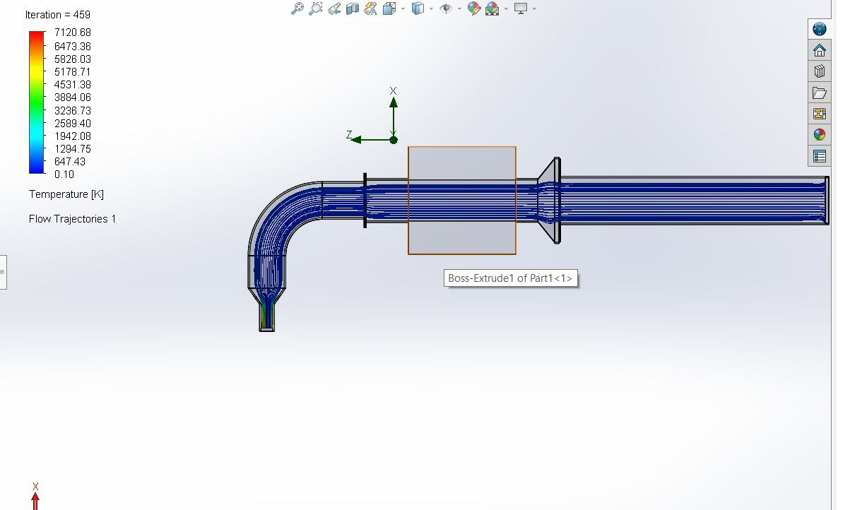
Results Overview
The simulation analyzed the temperature distribution and flow trajectories through a curved pipe system. The key findings are summarized below:

1. Temperature Distribution
- Temperature Range:
- Minimum: 0.10 K.
- Maximum: 7120.68 K.
- The temperature gradient is noticeable along the pipe, with higher temperatures concentrated near the inlet and gradually reducing along the flow path.
- The curved section and downstream areas exhibit a relatively stable temperature drop.

2. Flow Trajectories
- The flow trajectories display a smooth and consistent flow pattern throughout the pipe.
- Minor disruptions in the flow are observed at the bend due to the geometry, but the overall flow remains aligned with the pipe's axis.
- No significant flow separations or turbulence were detected.

3. Observations
- The fluid undergoes a notable change in temperature as it flows through the system, indicating heat transfer or thermal effects along the pipe.
- The curved section introduces minor velocity and temperature variations, as expected in such geometries.
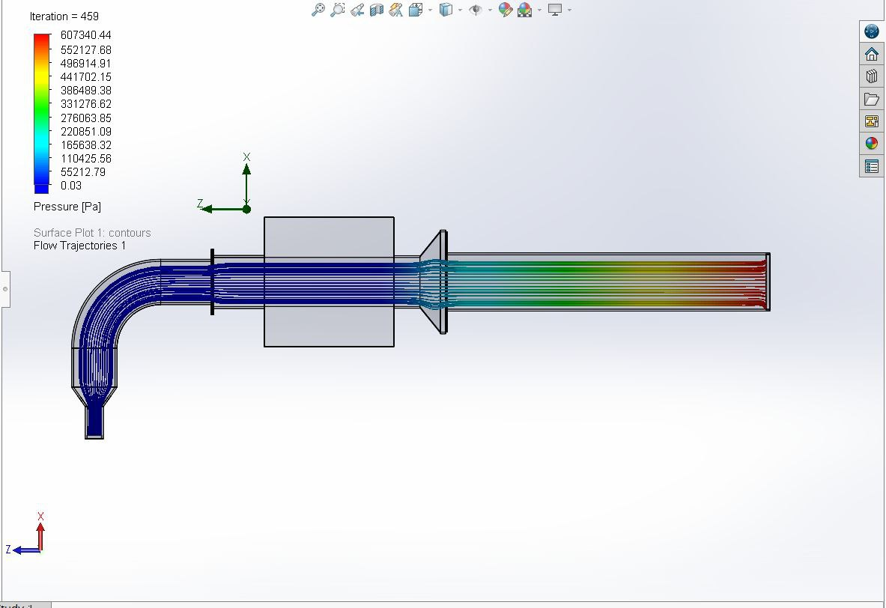

Objective
The purpose of this simulation was to evaluate the flow behavior and pressure distribution within the pipeline system under given boundary conditions. The study aimed to visualize the fluid flow patterns and identify areas of high pressure and flow velocity to ensure the design meets performance expectations.
Key Results
1. Pressure Distribution:
Maximum Pressure: 607,340.44 Pa
Observed at the inlet of the pipe system, indicating the initial high-pressure zone as the fluid enters the system.
Minimum Pressure: 0.03 Pa
Recorded near the outlet, showing that the pressure significantly decreases as the fluid exits the pipeline.

2. Flow Behavior:
Flow Trajectories:
Streamlines indicate smooth flow through most sections of the pipe, with some variations due to the bends and changes in pipe geometry. The streamlines also highlight potential areas of flow recirculation or turbulence.

Flow Pattern:
The flow accelerates at the constriction (nozzle-like section) and stabilizes in the straight section, aligning with fluid dynamics principles.
3. Critical Observations:
The highest pressure occurs at the inlet, gradually reducing along the flow path.
The bend in the pipeline contributes to minor pressure losses and potential turbulence.
Observations
1. Pressure Losses:
Pressure drops significantly after the bend and constriction, which aligns with the expected behavior due to fluid resistance and pipe geometry.

2. Flow Stability:
The flow appears well-behaved in the straight section after the constriction, ensuring consistent fluid delivery downstream.

3. Performance Assessment:
The design efficiently handles the fluid flow with no significant regions of instability or obstruction. However, high-pressure zones near the inlet may require reinforcement depending on operating conditions.
Conclusion
The flow simulation demonstrates that the pipeline system is well-designed to handle the fluid dynamics effectively. Pressure and flow patterns are consistent with expected results, and the design is suitable for the intended application. Minor optimizations may enhance efficiency and longevity.

5. Testing and Evaluation:
- After production, test the funnel to ensure that it works as required and is free of defects.
- Ensure that it can be handled easily and meets all functional requirements.

Operation Instruction

Preparation
- Precautions
  - The inlet air pressure should be 0.5-0.8Mpa and the working air pressure should be 0.4-0.5Mpa.
  - Keep all appendages clear of moving parts during operation.
- Filling amount troubleshooting
Adjust the filling amount as follows:
  - Put materials to be filled into the container.
  - Prepare measuring cup or scale to identify quantities desired.
  - Turn the hand wheel to adjust the variable sensor to desired range.
  - Check to ensure that the operation switch is set to Semiautomatic, use the foot pedal to control the cycle, measure the obtained product to see whether it is in the desired quantity. If not, proceed by the the following:
  - Loosen the locking handle on the adjustable sensor.
  - Turn the hand wheel clockwise or counterclockwise.
  - Repeat step 4, using a measuring cup or bottle to measure the materials and adjust the handwheel until the obtained result is within the desired range.
  - Tighten the locking handle on the adjustment sensor to avoid parts shifting and influencing the filling accuracy. (Clevelandequipment, 2024)

Operation Method
- Connect the air source and slide the air inlet collar towards the machine.
- Check whether the air pressure meter is in the specified range (roughly reading in the “12-3 o’clock” range). If not, draw the air pressure knob outwards to unlock, rotate the pressure regulator knob until the pressure is in the specified range (0.40.5Mpa) and push the knob back in to lock.
- Use the Auto/Semiauto switch to set the filler to the desired operation method.
- To make an adjustment, you can loose the locking handle on the adjustment sensor, rotate the handwheel, take note of the value on the position display and fasten the handle.

- Adjust the front valve (for adjusting drawing speed) and behind valve (for adjusting filling speed) as shown in Figure 1 to get reasonable drawing and filling speed.
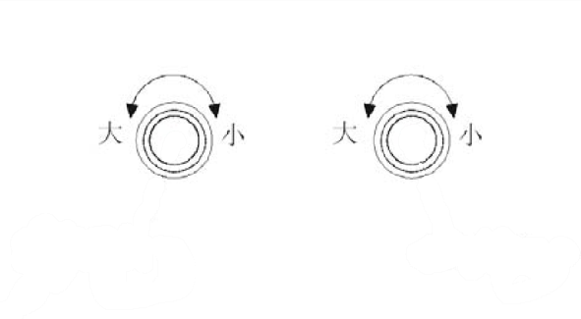

ࡽ

≄

ਾ

FORNTVALVE

BEHANDVALVE

Figure 1

Large
Large

Small

Small

Front valve of cylinder

Rear valve of cylinder

- Fill the hopper with product and prepare the container to be filled.
- Proceed with filling and control the operation with the foot switch. Step on the foot switch once to cycle a complete filling operation. You can adjust and use the Automatic function if you are proficient enough to keep up with the filling speed (Clevelandequipment, 2024).

Fault Analysis and Troubleshooting
Symptom | Analysis | Troubleshooting
The machine  fails | Check whether the air pressure collar is open | Open it
The machine  fails | Check whether the air source is open  (compressor) | Open it
The machine  fails | Check whether the value on air pressure meter is in the correct range | Adjust it to 0.4-0.5MPa
The machine  fails | Check whether there is leakage on any air fittings or damage on air lines | Insert the airline again or change another one
The machine  fails | Check whether air amount is adjusted to the minimum (tightened too much) via the front valve and behind valve | Adjust the valves to the working status
The machine  fails | Check whether the air amount on the fill head cylinder is adjusted to the minimum (tightened too far) | Adjust the throttle to the working status
The machine  fails | Check cleanliness of machine. Product may be hardened, tacky, or sticky, causing rotary assembly or main piston to be stuck | Clean the machine
Filling is not even | Check for air leakage in all air line connections | Fasten each joint
Filling is not even | Check for leakage in the product chamber | Replace O-rings
Filling is not even | Check product level inside hopper | Add materials
Filling is not even | Check for correct speeds during filling and drawing actions | Adjust the front valve and behind valve for stable operation
Filling is not even | Check whether the material viscosity is even | Agitate product
(Clevelandequipment, 2024)

Safety Instruction
- You can use soap and warm water to clean the machine. Fill hopper with cleaning agent and water; cycle until discharge is clear of any product; fill hopper with clean water and cycle until water is clear
- Never use sharp tools on any parts surface when cleaning the internal parts and install the parts when they are dry.
- Use lubricant for all moving parts.
- Check the O-rings of all parts and replace damaged rings.
- Check whether there is damage or leakage on the air lines.
- Fasten screws of all parts.
- Never clean the filler via harsh or abrasive cleaners to protect the machine integrity.
- Never cycle the filler without a product.
- Never put hard materials into the hopper.
- Filler should be on a flat surface in a dry place with little dust and enough room for movement during each filling cycle.
- Use the machine in air-current environment when volatile liquid is to be filled.
- Body or materials should be far away from moving parts and our factory takes no responsibility for any machinery and human injury due to it.
- Cut off the air source when repairing/replacing parts/cleaning.
- Never use an organic flux to clean the machine, such as gasoline, acetone, benzene, xylene, banana oil or sodium hypochlorite. (Clevelandequipment, 2024)

7. Filling speed
The filling speed is decided by the following 5 factors:
a) Sucking speed, which is decided by the material viscosity, and the rotary valve size (a standard rotary valve is provided on the machine.)
b) Filling nozzle size. With a larger nozzle size, the filling speed will be faster.
c) Material frothing speed. Filling speeding should be slower for highly
frothing products.
d) Filling amount. Filling speed should be slower with greater filling amount.
e) Filling accuracy. With higher filling accuracy, the filling speed should be slower.
Adjustment operation:
Loosen the adj. nuts (15) and (18) of the adj. valve and then
a) Turn the one-way valve handle (15) clockwise to slow down the cylinder (22)
forward travel speed an the charging speed;
b) Turn the handle (15) counterclockwise to accelerate the cylinder forward travel speed and the charging speed;
c) Turn the handle (18) clockwise to slow down the cylinder withdrawal speed and the material-sucking speed;
d) Turn the handle (18) counterclockwise to accelerate the cylinder withdrawal speed and the material-sucking speed. (filling machine, 2018)

References
.Mccormac, J. C. (2010). Structural Steel Design.
aliexpress. (n.d.). Retrieved from https://ar.aliexpress.com/item/1005004441199593.html.
Amazon. (2024). Retrieved from https://www.amazon.co.uk/Stainless-Hopper-Filling-Machine-Capacity/dp/B0CZ491Q2Z?ref=d6k_applink_bb_dls_failed&dplnkId=52358d3e-e083-473b-8621-dffbd92710f4.
c. (n.d.).
Clevelandequipment. (2024). Retrieved from https://www.goodwininc.com/2024/03/22/quality-control-in-chemical-liquid-filling/.
Esposito, A. (2014). Fluid power with applications.
filling machine. (2018). Retrieved from https://www.scribd.com/document/385686401/Manual-Maquina-de-Inyeccion-de-Plastico.
FK SPEEDA. (2023). Retrieved from https://images.app.goo.gl/gqYEUNwmwftbXTnV9.
GradCAD. (2023). Retrieved from https://grabcad.com/library/fully-automatic-clamp-pull-vertical-packaging-machine-1.
J.L.Meriam. (1807). Engineering Mechanics Dynamics.
J.L0MERIAM. (1807). engineering mechanics statics.
ROBERSON, J. A. (1976). Engineering Fluid Mechanics. United state.
ROBERSON, J. A. (1976). Engineering Fluid Mechanics. Untited state.
Solidprize. (2019). Retrieved from https://www.solidprize.com.br/2019/04/envasadora-com-misturador-de-passagem.html.
(2020). Thapar University.
V.B.Bhandari. (1994). Design of Machine Elements .

